**Experiment: 1**

**Aim:** Create a user define function named sum which accept 2 arguments (of integer type) and return the sum of them

**Software:** Dev C++

**Code:**

**#include<stdio.h>**

**int sum(int a, int b)**

**{**

**return a+b;**

**}**

**int main()**

**{**

**int a,b;**

**printf("Enter The First Value:-");**

**scanf("%d",&a);**

**printf("Enter The Second Value:-");**

**scanf("%d",&b);**

**printf("The Addition of %d and %d is %d",a,b,sum(a,b));**

**return 0;**

**}**

**Output:**

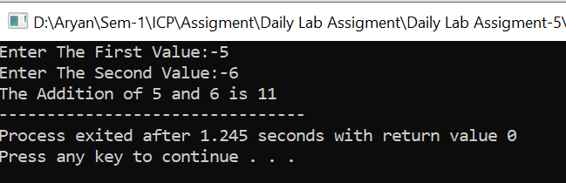

**Experiment: 2**

1. **Aim:** Create a user define function named evenodd which accept one argument (of integer type) and return if the number is even or odd.

**Software:** Dev C++

**Code:**

**#include<stdio.h>**

**void evenodd(int a)**

**{**

**if(a%2==0)**

**{**

**printf("%d Is A Even Number",a);**

**}**

**else**

**{**

**printf("%d Is A Odd Number",a);**

**}**

**}**

**int main()**

**{**

**int a;**

**printf("Enter A Number:-");**

**scanf("%d",&a);**

**evenodd(a);**

**return 0;**

**}**

**Output:**

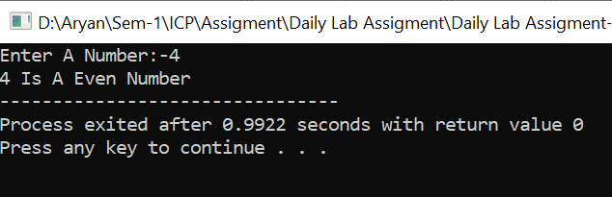

**Experiment: 3**

**Aim:** Create a user define function named power which accept two arguments (of integer type) (i) base (ii) expon and display the base^expon value

**Software:** Dev C++

**Code:-**

**#include<stdio.h>**

**#include<math.h>**

**int power(int base,int exp)**

**{**

**int ans;**

**ans=pow(base,exp);**

**return ans;**

**}**

**int main()**

**{**

**int base,exp;**

**printf("Enter The Base:-");**

**scanf("%d",&base);**

**printf("Enter The Power:-");**

**scanf("%d",&exp);**

**printf("%d Raise to %d Is %d",base,exp,power(base,exp));**

**return 0;**

**}**

**Output:**

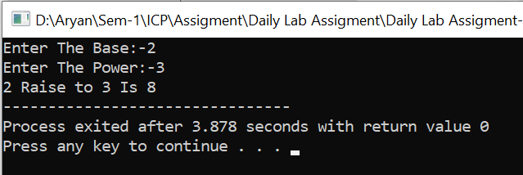

**Experiment: 4**

**Aim:**  Write a void function which count the area and perimeter of circle(Call By Reference) witch passes radius , address of area variable and address of  perimeter variable with declaration like Void count(float , float *, float *)

**Software:** Dev C++

**Code:-**

**#include<stdio.h>**

**#define PI 3.14159**

**void area_perimeter(double *radius,double *area,double *perimeter)**

**{**

**\*area = PI * (*radius) * (*radius);**

**\*perimeter= 2*PI*(*radius);**

**printf("The Perimeter Of A Circle Is %lf\n",*perimeter);**

**printf("The Area Of A Circle Is %lf\n",*area);**

**}**

**int main()**

**{**

**double radius,area,perimeter;**

**printf("Enter The Radius:-");**

**scanf("%lf",&radius);**

**area_perimeter(&radius,&area,&perimeter);**

**return 0;**

**}**

**Output:-**

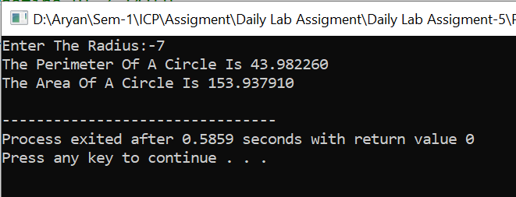

**Experiment: 5**

1. **Aim:-**  Write a function to find out maximum from of n no of values. User has to pass n no of elements and Address of first variable in an array. With declaration like int findmax(int,int *).

**Software:-** Dev C++

**Code:-**

**#include<stdio.h>**

**void maxn(int n,int *a[n])**

**{**

**int max= *a[0];**

**for(int i=0;i<n;i++)**

**{**

**printf("Enter The Value At Index-%d:-",i+1);**

**scanf("%d",&a[i]);**

**}**

**for(int i=0;i<n;i++)**

**{**

**if(*a[i]>max)**

**{**

**max= *a[i];**

**}**

**}**

**printf("The Maximum Value In Array Is %d",max);**

**}**

**int main()**

**{**

**int n;**

**printf("Enter The Size Of An Array:-");**

**scanf("%d",&n);**

**int *a[n];**

**maxn(n,&a[n]);**

**return 0;**

**}**

**Output:-**